IT IS EXTREMELY IMPORTANT THAT YOU PAY YOUR FULL ATTENTION TO THE EXPERIMENT.
Therefore, we kindly ask you to:

- Find a quiet, calm space to do this study. Please turn off your phone and other media to reduce distractions.

- Only participate from your desktop computer.

- Do not exit the experiment once it has begun. Due to the software we are using, we cannot guarantee you that you will be able to come back to the experiment and that your data can be recorded properly. In that case, we cannot compensate you for your time. Keep in mind the whole study should not take you more than 5 minutes.

- Focus on the tasks and respond attentively, but promptly.

Not following these instructions can affect your compensation. If you fail to respond to 10% or more of the trials in this experiment, you will not receive (full) compensation. Thank you for your time and understanding.

Description: In this survey you will take part in a couple of tasks dealing with your opinions about a robotic dog.

Risks and Benefits: You will not be exposed to any sensitive topics. There appear to be no risks and discomforts associated with the session other than the ones common in everyday life.

Time Involvement: Your participation in this part of the session will take approximately 15 minutes.

Confidentiality and anonymity: All published and written data that may result from these studies will only be shared in an aggregate form and will be anonymous.

Compensation: You will receive credits for this session (exact amount announced in Sona) if you follow up on all instructions. If you fail to respond to 10% of the trials in this experiment, you will receive 1 credit less. If you do not finish the survey, you will not receive your credits.

Participation: Participation in this research study is completely voluntary. You have the right to withdraw at anytime or refuse to participate entirely. If you wish to stop participating, no credits will be allocated. You can participate in other sessions instead.

Contact Information: If you have any questions, concerns, or complaints, please contact Femke van Horen (femke.van.horen@vu.nl).

For the following task, we are interested in how you perceive different objects.

On each screen, you will see two objects.

To get familiar with the task, you will first do a practice round.

You will see two citrus fruits. We will ask you to indicate which of the two citrus fruits you like more.

If you like the fruit on the left more, press D
If you like the fruit on the right more, press K

Please focus on the task and answer as fast as you can without thinking too much. We are interested in your initial responses, there are no right or wrong answers.

You can position your index fingers on the required keys: left index finger on D, and the right index finger on K.

Please note that WE WILL BE CHECKING YOUR ATTENTION throughout the experiment.

In attention check trials, you will see TWO IDENTICAL IMAGES on the screen.
You will be asked to PRESS Q instead of K or D like in other trials.

Attention check trials are NOT TIMED, so you will have enough time to respond.

Now that you are familiar with the task, we continue with the main task.

The main task is about ROBOTIC ARMS (CONDITION 1)

A robotic arm is a mechanical device consisting of linked segments and joints. It is designed to mimic the movements and functionalities of a human arm in various medical tasks.

In rehabilitation, robotic arms help patients regain movement after injuries such as stroke or broken joints. They provide controlled, repeatable assistance, adapting to a patient’s progress and enabling high-intensity training.

Please imagine that you have broken your hand and you need rehabilitation to restore mobility and strength. A robotic arm, instead of a physiotherapist, is used to do the exercises with you.

Now take a minute to picture that you will have to hold the robotic hand in order to do the exercises. The core of the robotic hand is made of mechanical components and feels stiff and cool when touched. As you hold it during the exercises, you can clearly feel its cool temperature and stiffness.

The main task is about ROBOTIC ARMS (CONDITION 2)

A robotic arm is a mechanical device consisting of linked segments and joints. It is designed to mimic the movements and functionalities of a human arm in various medical tasks.

In rehabilitation, robotic arms help patients regain movement after injuries such as stroke or broken joints. They provide controlled, repeatable assistance, adapting to a patient’s progress and enabling high-intensity training.

Please imagine that you have broken your hand and you need rehabilitation to restore mobility and strength. A robotic arm, instead of a physiotherapist, is used to do the exercises with you.

Now take a minute to picture that you will have to hold the robotic hand in order to do the exercises. The robotic hand is equipped with heating elements that regulate its temperature, making it feel warm and flexible to touch. As you hold it during the exercises, you can clearly feel the warmth and flexibility.

In the next three tasks, you will evaluate a set of robotic arms on different dimensions. On each screen, you will see two pictures next to each other, each of a robotic arm holding a human hand, and you will be asked to make a judgment.

We now start with the first task. Please read the instructions carefully.
As in the practice trials, you will see two pictures of a robotic arm holding a human hand next to each other. Please focus on the robotic arm. In this first task, you will be asked to indicate which of the two robotic arms you like more.

If you like the robotic arm on the left more, press D
If you like the robotic arm on the right more, press K

Please focus on the task and answer as fast as you can without thinking too much. We are interested in your initial responses; there are no right or wrong answers.

You can position your index fingers on the required keys: left index finger on D, and the right index finger on K.

Please note that WE WILL BE CHECKING YOUR ATTENTION throughout the experiment!

Before the task begins, you will first see what the task looks like.
Your task is to decide which of the two robotic arms you LIKE MORE.
ROBOTIC ARM B
ROBOTIC ARM A

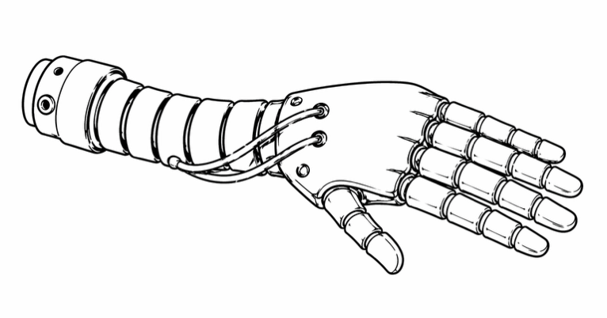 |  | 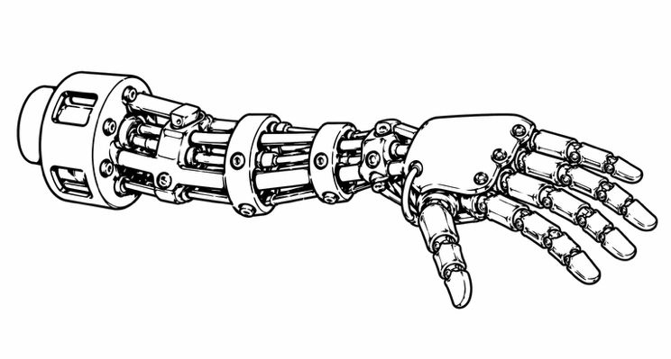

If you like the left one more (ROBOTIC ARM A), you PRESS D

If you like the right one more (ROBOTIC ARM B), you PRESS K

For Jeroen: On the next pages the randomized trials are shown. Please keep the following text each time above the display of the two arms (for condition 1):
Imagine you need to do rehabilitation exercises with a robotic hand which is stiff and cold.
Your task is to decide which of the two robotic arms you LIKE to hold MORE.

For Jeroen: On the next pages the randomized trials are shown. Please keep the following text each time above the display of the two arms (for condition 2):
Imagine you need to do rehabilitation exercises with a robotic hand which is flexible and warm.
Your task is to decide which of the two robotic arms you LIKE to hold MORE.

Thank you, the first task is finished!

Now, we will again show you the same robotic arms. This time it is your task to indicate which of the two robotic arms you think is more EERIE.

Eerie refers to a feeling of unease or discomfort that is unsettling (strange, unnatural).

If the robotic arm on the left feels more eerie, press D
If the robotic arm on the right feels more eerie, press K

You can position your index fingers on the required keys: left index finger on D, and the right index finger on K.

For Jeroen: On the next pages the randomized trials are shown. Please keep the following text each time above the display of the two arms (condition 1):
Imagine you need to do rehabilitation exercises with this robotic hand which is stiff and cold.
Your task is to decide which of the two robotic arms feels more EERIE.

For Jeroen: On the next pages the randomized trials are shown. Please keep the following text each time above the display of the two arms (condition 2):
Imagine you need to do rehabilitation exercises with this robotic hand which is flexible and warm.
Your task is to decide which of the two robotic arms feels more EERIE.

Thank you, the second task is finished!

Now, we will again show you the same robotic arms. This time it is your task to indicate which of the two robotic arms is more similar to a human arm.
If the robotic arm on the left is more similar, press D
If the robotic arm on the right is more similar, press K

Please focus on the task and answer as fast as you can without thinking too much. We are interested in your initial
responses, there are no right or wrong answers.

Before the task begins, you will first see what the task looks like.

Your task is to decide which of the two robotic arms at the bottom is
MORE SIMILAR TO THE HUMAN ARM ON TOP.

If you think the right one (ROBOTIC ARM B), is more similar
you PRESS K.
If you think the left one (ROBOTIC ARM A), is more similar
you PRESS D.

 | 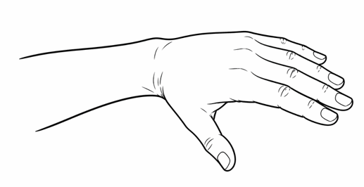
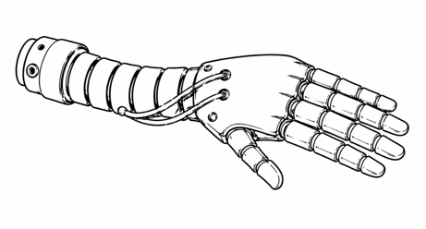  ROBOTIC ARM A |  | 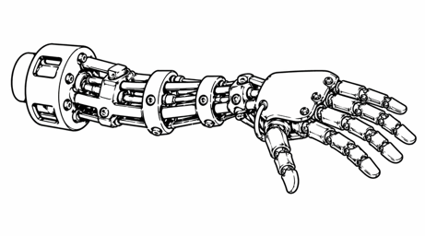  ROBOTIC ARM B

For Jeroen: On the next pages the randomized trials are shown. Please keep the following text each time above the display of the two arms (for both conditions):
Your task is to decide which of the two robotic arms is more SIMILAR to the human arm on top.

Demographics

- Age
- Gender
- To what extent are you familiar with robotic arms in health care (1 not at all – 7 very much)

- Jeroen: underneath you find seveal personality characteristics scales. I am not sure if we should program them in the psychopy experiment or in a separate qualtrics experiment. If the first, it is important that the different items are indicated clearly (maybe alternating grey vs white colored items?), so students do not get bored, and can read the different items easily. If we choose for the last option, we will need to make sure that the data can be linked. So the students need to indicate the correct ID number twice. I am not sure if that is too risky. Can you redirect the experimetn to a qualtrics experiment or is that difficult?

Next page

Provide instructions:
Underneath you will find several statements. Please indicate the extent in which you agree with the statements, from 1 = do not agree at all to 7 = totally agree. There are no right or wrong answers, we are interested in your opinion.

1-7 likert scale totally disagree to totally agree.

2. It is absurd to consider a human being and a robot to be the same kind of thing. (.78)
3. Human beings have a soul, which a robot could never have. (.77)
4. Even if a robot might one day seem human, it would never be anything like a real human
being. (.77)
6. In a sense, human beings are nothing more than highly sophisticated, self-replicating
robots.R (.73)
7. It would be alright if someday we could not tell robots from human beings.R (.72)
8. Human beings are fundamentally different from robots. (.72)

Next page

Technology anxiety (general anxiety with all forms of technology and were assessed on a seven-point likert scale with endpoints strongly agree to strongly disagree. Higher scores indicate higher levels of anxiety). Meuter, M. L., Ostrom, A. L., Bitner, M. J., & Roundtree, R. (2003). The influence of technology anxiety on consumer use and experiences with self-service technologies. Journal of business research, 56(11), 899-906. => items 1-3.

- I feel apprehensive about using technology.
- I have avoided technology because it is unfamiliar to me.
- I am able to keep up with important technological advances.
- I feel anxious when using new technologies.

Next page

Full disgust sensitivity scale
